**A**

**Project Report**

**on**

**E-Commerce Store**

**Developed By**

***Nanda Amit [2205112110060]***

**developed at**

**Instance It Solutions**

**as**

**Partial Fulfillment of IVth Semester of**

**Master of Computer Applications for A.Y. 2023 - 2024**

**Under The Guidance of**

**Prof. Faruk Abdulla**

**Submitted To**

**Department of MCA**

**Faculty of IT & Computer Science**

**PARUL University**





**CERTIFICATE**

This is to certify that **Mr. Nanda Amit Enrollment No. 2205112110060**  student of Master of Computer Applications have satisfactorily completed the Major Project on **“Salesport E-commerce Website”** at **Instance It Solutions** as fulfillment of MCA Semester IV.

Seat No. ___________ Date of Submission: ____________

_______________ _______________ _______________

Internal Guide Project Coordinator Director - MCA

**Department of MCA**

**Faculty of IT & Computer Science**

**PARUL University, Vadodara.**

**INDEX**

|  |  |  |
| --- | --- | --- |
| **No.** | **Description** | **Page No.** |
| **1.** | **Company Profile** | **1** |
| **2.** | **Project Profile**  • Project Definition  • Project Description  • Existing / Legacy System  • Problem Statements  • Needs for New System  • Proposed System  • Scope  • Outcomes  • Tools & Technology used with short justification | **2** |
| **3.** | **Requirement Analysis**  3.1 Feasibility Study  3.2 Users of the System  3.3 Modules  3.4 Process Model  3.5 Hardware & Software Requirements  3.6 Use Cases  3.7 Use Case Diagram | **3** |
| **4.** | **Design**  • Use Case Scenarios  • Diagrams [Structured OR OOAD]  **Structured:**  ▪ Data Flow Diagram  ▪ Flow Chart  ▪ Structure Diagram  **OOAD:**  ▪ Class Diagram  ▪ Sequence Diagram  ▪ Activity Diagram  ▪ Collaboration Diagram  ▪ Deployment Diagram  • Entity Relationship Diagram  • Data Dictionary | **7** |
| **5.** | **Implementation**  • Form Layouts  • Page Layouts  • Report Layouts  • Coding Conventions [Business Logic] | **13** |
| **6.** | **Testing**  • Test Strategy  • Test Cases | **30** |
| **7.** | **Future Enhancement** | **62** |
| **8.** | **Bibliography** | **63** |

1. **Company Profile**

**2 .Project Profile**

**1. Project Definition:**

The Salesport E-commerce Website aims to establish an online platform dedicated to sports-related products. It serves as a marketplace for athletes, sports enthusiasts, and fitness aficionados to purchase a wide range of sporting goods conveniently.

Project definition refers to the initial phase of a project where the project objectives, scope, deliverables, and constraints are identified and documented. It essentially sets the foundation for the entire project. During this phase, key stakeholders come together to establish a clear understanding of what the project aims to achieve and how it will be executed

**Objective:**

* Develop an online platform dedicated to sports-related products, providing a comprehensive marketplace for athletes, sports enthusiasts, and fitness aficionados to conveniently purchase sporting goods.

**Scope:**

* Design, develop, and deploy a user-friendly e-commerce website tailored specifically for the sports industry.
* Offer a wide range of sports products including equipment, apparel, and accessories.
* Implement specialized features and functionalities catering to the preferences and requirements of sports enthusiasts.
* Ensure secure payment processing, efficient order management, and seamless user experience across devices.

**Target Audience:**

* Sports enthusiasts, athletes, fitness professionals, and individuals interested in sports-related activities.
* Vendors and manufacturers of sports products seeking a platform to showcase and sell their merchandise.

**Key Features:**

* User authentication and account management.
* Comprehensive product catalog with advanced search and filtering options.
* Detailed product listings with images, descriptions, and reviews.
* Shopping cart functionality with secure checkout process.
* Order tracking and management system.
* Personalized user experience with product recommendations.
* Responsive design for accessibility across various devices.
* Admin panel for managing products, orders, and site settings.

**Technology Stack:**

* Frontend: HTML, CSS, JavaScript, Bootstrap for responsive design.
* Backend: PHP for server-side scripting.
* Database: MySQL for data storage and management.
* Additional technologies such as Ajax for asynchronous communication and enhancing user experience.

**2.Project Description:**

* The project involves designing, developing, and deploying an e-commerce website tailored specifically for the sports industry. The platform will offer a user-friendly interface for browsing products, making purchases, and managing orders efficiently.

**3.Existing / Legacy System:**

* Currently, there might be a lack of a dedicated e-commerce platform exclusively for sports products, or existing platforms may not provide a comprehensive selection or user experience tailored to sports enthusiasts.

**4.Problem Statements:**

* Limited options for purchasing sports-related products online.
* Lack of specialized features catering to the needs of sports enthusiasts.
* Inconvenient user experience on existing e-commerce platforms for sports products.

**5.Needs for New System:**

* Comprehensive selection of sports products.
* User-friendly interface with intuitive navigation.
* Features tailored to the preferences and requirements of sports enthusiasts.
* Secure payment gateway and robust order management system.

**6.Proposed System**:

* The proposed system involves the development of a dedicated e-commerce website, Salesport, which offers a vast array of sports products, including equipment, apparel, and accessories. It will incorporate specialized features such as advanced search filters, product recommendations based on user preferences, and interactive elements like user reviews and ratings.

**7.Scope:**

* Design and development of the e-commerce website.
* Implementation of user authentication and authorization mechanisms.
* Integration of payment gateways for secure transactions.
* d. Incorporation of inventory management and order tracking functionalities.
* e. Implementation of responsive design for seamless user experience across devices.
* f. Deployment and testing of the website to ensure functionality and security.

**8.Outcomes:**

* Establishment of a comprehensive online marketplace for sports products.
* Enhanced user experience with tailored features and intuitive interface.
* Increased accessibility to sports products for enthusiasts worldwide.
* Improved revenue generation opportunities for sports product vendors.
* Strengthened online presence and brand recognition for Salesport.

**9.Tools & Technology used with short justification:**

**HTML (HyperText Markup Language):**

* Justification: HTML is the standard markup language for creating web pages and structuring content. It provides the foundation for building the structure of the website, including elements like headings, paragraphs, images, and links.

**CSS (Cascading Style Sheets):**

* Justification: CSS is used for styling the HTML elements, defining layout, colors, fonts, and other visual aspects of the website. It helps in creating a visually appealing and consistent user interface across different web pages.

**JavaScript:**

* Justification: JavaScript is a versatile programming language that adds interactivity and dynamic behavior to web pages. It's essential for implementing client-side functionalities such as form validation, DOM manipulation, and interactive elements like sliders or accordions.

**Bootstrap:**

* Justification: Bootstrap is a popular front-end framework that provides a set of pre-designed components, layouts, and utilities for building responsive and mobile-first websites. It enables rapid prototyping and simplifies the process of creating a responsive design, ensuring compatibility across various devices and screen sizes.

**Ajax (Asynchronous JavaScript and XML):**

* Justification: Ajax is a technique used for asynchronous communication between the client-side and server-side, allowing parts of a web page to be updated without requiring a full page reload. It enhances user experience by enabling smoother and faster interactions, such as dynamic content loading and form submission without page refresh.

**PHP (Hypertext Preprocessor):**

* Justification: PHP is a server-side scripting language commonly used for web development. It enables the dynamic generation of web pages, processing form data, interacting with databases, and implementing server-side functionalities like user authentication and session management.

**MySQL:**

* Justification: MySQL is a popular open-source relational database management system (RDBMS) used for storing and managing data in a structured format. It provides robust database capabilities for the e-commerce website, such as storing product information, user profiles, orders, and other essential data.
* Using this technology stack, the Salesport E-commerce Website can be efficiently developed with a combination of robust server-side processing (PHP and MySQL) and dynamic client-side interactions (HTML, CSS, JavaScript, Bootstrap, and Ajax), resulting in a feature-rich and responsive online platform for sports enthusiasts.

1. **Requirement Analysis**

|  |
| --- |
| **Project** |
| Salesport E-commerce website |
| **Technical Feasibility:** |
| A thorough analysis of the current technological infrastructure will be conducted to determine its compatibility with the proposed upgrades. This includes assessing the compatibility of existing hardware, software, and network infrastructure with the latest technologies and platforms. |
| **Economic Feasibility** |
| comprehensive cost-benefit analysis will be conducted to evaluate the financial feasibility of the project. This includes estimating the costs associated with development, implementation, training, and maintenance, and comparing them against the expected benefits, such as increased sales, improved customer satisfaction, and enhanced competitiveness. |
| **Operational Feasibility** |
| User acceptance testing (UAT) will be conducted to assess the usability and effectiveness of the upgraded system from the perspective of end-users. Feedback from stakeholders and end-users will be gathered and incorporated into the final system design to ensure that it meets their needs and expectations. |
| **Implementation Feasibility** |
| Implementation Feasibility deals with the study of whether the service is environment available with all association members and will be managed according to the system or not. |

**3.1 Feasibility Study**

* The feasibility study is an evaluation and analysis of the potential of a project which is based on extensive investigation and research to support the process of decision making. Depending on the result of the initial

*Table1 . Feasibility Study Table*

**3.2 Users of the System:**

* Identify the various users who will interact with the system, including:
* Customers: Users browsing and purchasing sports products.
* Administrators: Users managing products, orders, and site settings.
* Vendors: Users adding and managing their sports products for sale on the platform.
* Define the roles and responsibilities of each user type within the system.

**3.3 Modules:**

* Define the functional modules/components of the system, including:
* User Authentication and Management
* Product Management
* Shopping Cart and Checkout
* Order Management
* Search and Filtering
* Admin Panel
* Reporting and Analytics

**3.4 Process Model**:

* Choose an appropriate process model for software development, such as Agile, Waterfall, or Iterative.
* Define the phases of development, including requirements gathering, design, implementation, testing, deployment, and maintenance.
* Determine the workflow and activities involved in each phase, along with the roles and responsibilities of team members.

**Agile methodology**

The Agile methodology is an iterative and incremental approach to software development that prioritizes flexibility, collaboration, and customer feedback. It emphasizes adaptability to changing requirements and focuses on delivering working software in short iterations, Agile teams are cross-functional, comprising members with diverse skill sets, including developers, designers, testers, and business analysts. This allows for greater collaboration and accountability within the team, leading to faster and more efficient development. Agile prioritizes delivering working software that provides tangible value to the customer.

known as sprints. Here's an overview of the key principles and practices of Agile methodology:

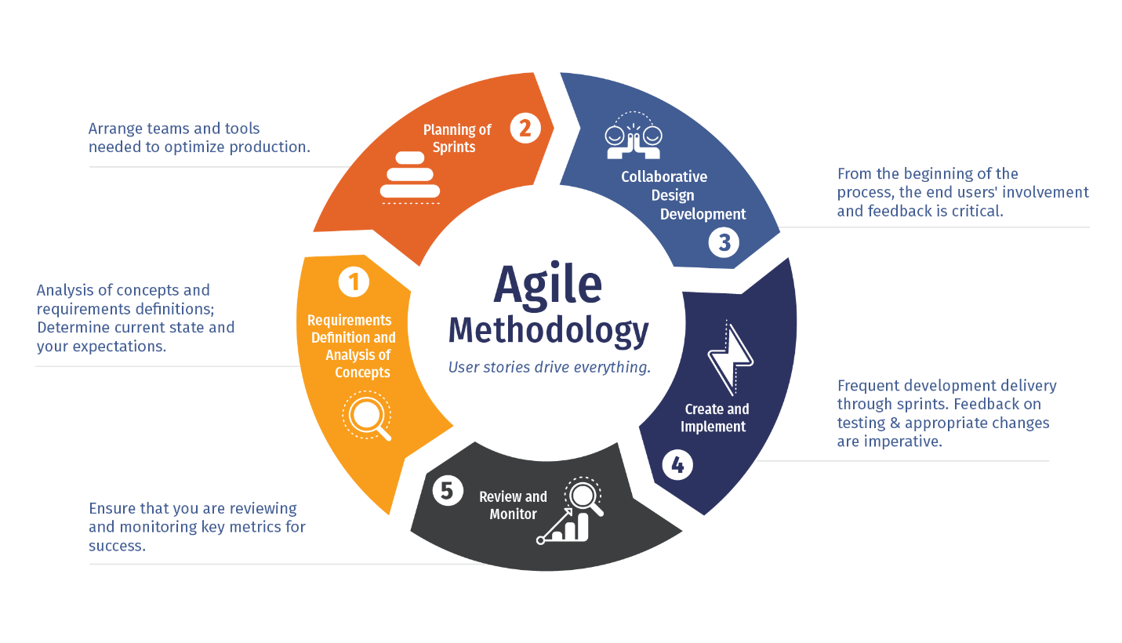

* *Figure1. Agile Model Life Cycle*
* **Iterative Development**: Agile breaks down the development process into small iterations, typically lasting 2-4 weeks. Each iteration results in a potentially shippable product increment, allowing for continuous delivery of value to the customer.
* **Customer Collaboration**: Agile places a strong emphasis on customer collaboration throughout the development process. Customers and stakeholders are actively involved in providing feedback, reviewing progress, and prioritizing features.
* **Cross-Functional Teams**: Agile teams are cross-functional, comprising members with diverse skill sets, including developers, designers, testers, and business analysts. This allows for greater collaboration and accountability within the team, leading to faster and more efficient development.
* **Adaptive Planning**: Agile projects embrace change and prioritize responding to customer feedback and market dynamics. Instead of rigidly adhering to a predefined plan, Agile teams engage in adaptive planning, continuously refining requirements and adjusting priorities based on evolving needs.
* **Continuous Improvement**: Agile fosters a culture of continuous improvement through regular reflection and adaptation. At the end of each iteration, teams conduct retrospectives to reflect on what went well.
* **Embracing Change**: Agile recognizes that change is inevitable and welcomes it as a natural part of the development process. Instead of viewing change as a disruption, Agile teams embrace it as an opportunity to deliver greater value to the customer.
* **Focus on Delivering Value**: Agile prioritizes delivering working software that provides tangible value to the customer. By breaking down the project into small, manageable chunks and delivering incremental improvements, Agile teams ensure that value is continuously delivered throughout the development lifecycle.

**Advantages:**

* Flexibility in responding to changing requirements and priorities
* Increased customer satisfaction through continuous value delivery
* Faster time to market with iterative development
* Improved software quality with continuous testing
* Enhanced collaboration and adaptability within teams

**Disadvantages:**

* Lack of predictability in project timelines and costs
* Resource-intensive due to high collaboration and involvement
* Dependency on customer availability for feedback
* Risk of scope creep with continuous addition of features
* Documentation challenges prioritizing working software over documentation
* Requirement of dedicated and available team members.

**3.5 Hardware & Software Requirements:**

* Identify the hardware and software infrastructure required to support the system, including:
* Server requirements for hosting the website and database.
* Development environment for designing, coding, and testing.
* Software dependencies such as web servers, database management systems, and development frameworks.

**Server-Side Requirements**

* Hardware

|  |  |
| --- | --- |
| Ram | 2 GB |
| SSD | Not Necessary |

*Table.2 Hardware Requirements*

|  |  |
| --- | --- |
| Operating System | Windows 11 |
| Database | MY SQL |
| Backend | PHP |
| Front-End | HTML,CSS,Bootstrap,Javascript,Ajax,JQuery |
| Tool | Visual Studio Code |

* Software

**Client-Side Requirements**

|  |  |
| --- | --- |
| Ram | 4 GB |
| Device | Android Device |

Hardware

*Table.4 Hardware Requirements*

* Software

|  |  |
| --- | --- |
| Operating System | Window |
| Application software | XAMP/WAMP |
| Fronted | HTML,CSS,Bootstrap, JavaScript |
| Backend | MYSQL, API |
| Language | PHP |

**3.6 Use Cases:**

* Define various use cases to capture functional requirements and user interactions with the system.
* Describe the specific actions or tasks users can perform within the system, along with the system's response.
* Examples of use cases include user registration, product search, adding items to the shopping cart, placing orders, etc.

**3.7 Use Case Diagram:**

* Create a graphical representation of the system's use cases and their relationships using a use case diagram.
* Illustrate the actors (users) and their interactions with the system through various use cases.
* Show how different use cases are related to each other and to the system as a whole.
* Salesport E-commerce Website project, ensuring clarity and alignment with project goals and objectives.

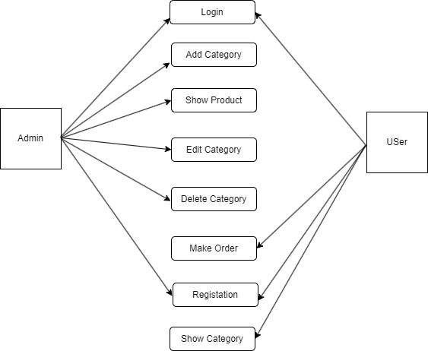

|  |
| --- |
| Use Case Diagram |

**4. Design**

* 1. **Use Case Scenarios**

|  |  |
| --- | --- |
| Name of the use case | User Registration |
| Actor | New User, System |
| Primary flow of event | 1. New User navigates to the registration page. 2. New User fills out the registration form with required details. 3. System validates the information and creates a new user account. 4. User receives a confirmation email with account activation link. 5. User activates the account by clicking the link. 6. User logs in using the registered email and password. |
| Alternative flow of event | If the provided email address is already associated with an existing account, the system prompts the user to log in instead of registering a new account. |
| Pre-condition | User has access to the internet and a valid email address. |
| Post-condition | User successfully registers for an account and can log in to access their account information. |
| Use case termination | User completes the registration process and gains access to their account, or user cancels the registration midway. |

*Table.6. Use Case Scenario for registration*

|  |  |
| --- | --- |
| Name of the use case | Login |
| Actor | User |
| Primary flow of event | Username, Password |
| Pre-condition | Admin must have login the systems |
| Alternative flow of event | If username or password wrong show message |
| Post-condition | If successful login and come to Home Page. |
| Use case termination | Cancel |

*Table 6: Use Case Scenarios for Login*

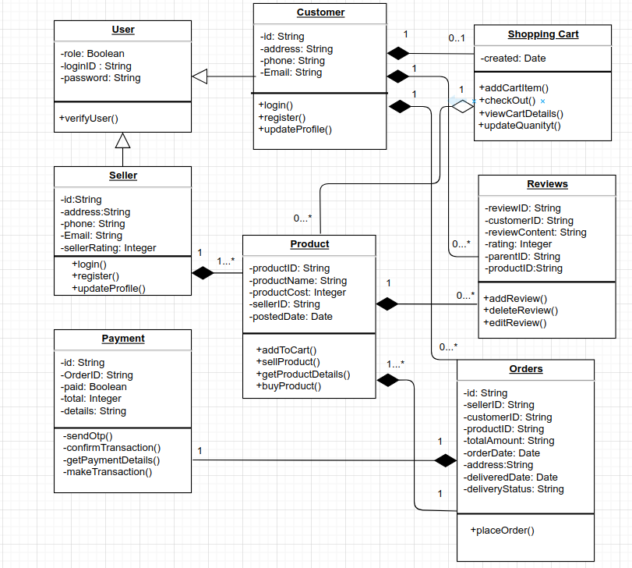

**4.3 Structured:**

▪ **Data Flow Diagram**

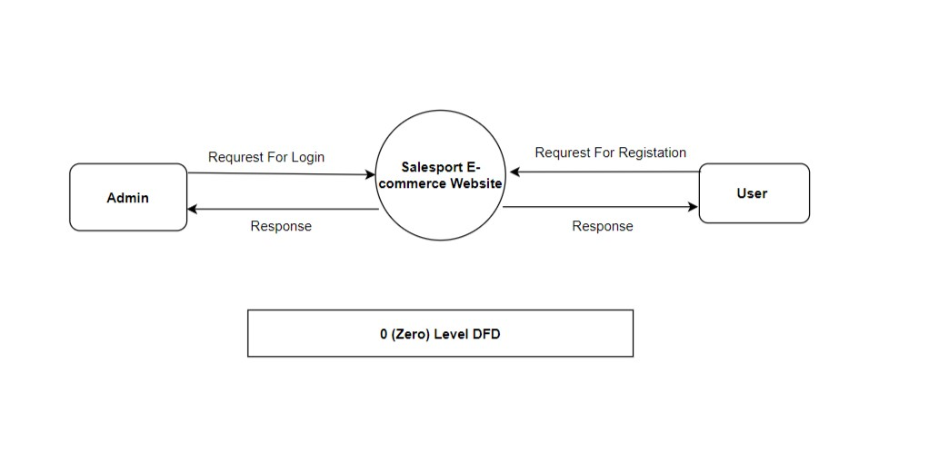

0sdsdnsssi

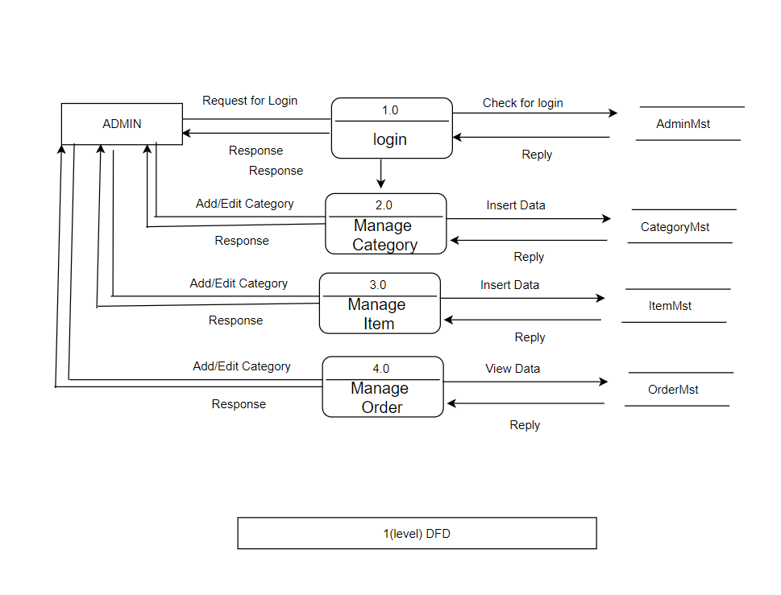

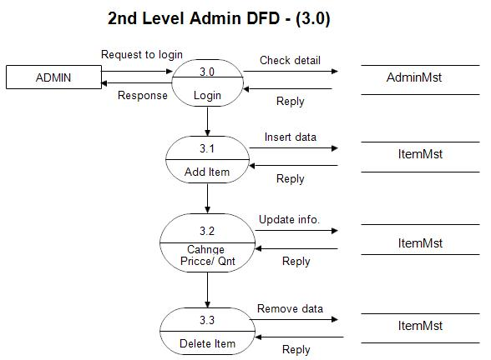

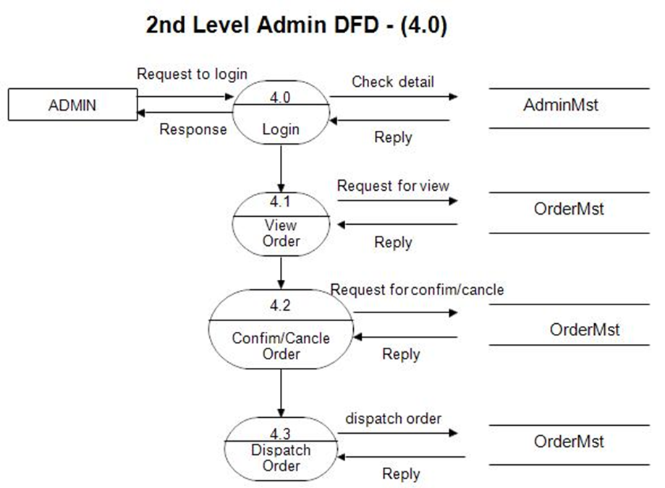

• **Entity Relationship Diagram**

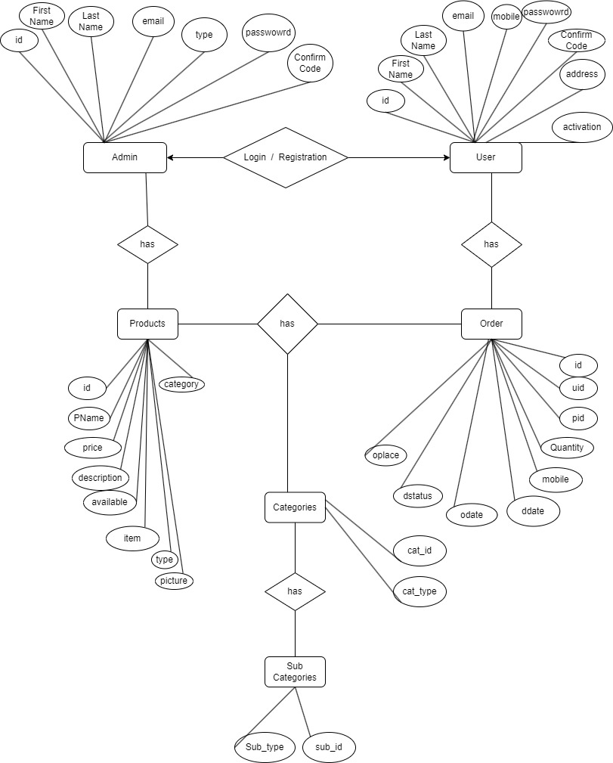

**• Data Dictionary**

1. **User Table**

|  |  |  |  |
| --- | --- | --- | --- |
| **Fields** | **Constraints** | **Datatype** | **Description** |
| id | PK, Auto increment | bigint | Id of user |
| firstNane | Not null | Varchar(25) | First name of user |
| lastName | Not null | Varchar(25) | Last name of user |
| Email | Not null | Varchar(100) | Email of user |
| Mobile | Not null | varchar(20) | number of user |
| Address | Not null | Varchar(120) | Address of user |
| Password | Not null | Varchar(100) | Password of user |
| Confirmcode | Not null | Varchar(10) | Confirmcode of user |
| Activation | Not null | Varchar(10) | Activation of user |

1. **Order product**

|  |  |  |  |
| --- | --- | --- | --- |
| **Fields** | **Constraints** | **Datatype** | **Description** |
| Id | PK, auto increment | bigint | OrderProduct id |
| Uid | FK, not null | bigint | Order id |
| Pid | FK, not null | bigint | Product id |
| Quantity | not null | int | Quantity |
| Oplace | Not null | Integer | Oplace |
| Mobile | not null | Integer | Mobile number of order |
| Dstatus | not null | Varchar(10) | Dstatus of order |
| Odate | not null | datetime | Created date |
| Ddate | not null | Datetime | Delete data |

1. **Login**

|  |  |  |  |
| --- | --- | --- | --- |
| **Fields** | **Constraints** | **Datatype** | **Description** |
| User_id | not null | bigint | User id |
| Password | not null | Varchar(20) | Password of login |

1. **Products**

|  |  |  |  |
| --- | --- | --- | --- |
| **Fields** | **Constraints** | **Datatype** | **Description** |
| id | PK, auto increment | bigint | Product id |
| Pname | not null | varchar(256) | Product name |
| Price | not null | Integer | price |
| Description | not null | Longtext | Description |
| Available | not null | Varchar(100) | Available of product |
| Category | not null | Varchar(100) | Category of product |
| Type | not null | Varchar(100) | Type of product |
| Item | not null | Varchar(100) | Item of product |
| Pcode | not null | Varchar(100) | Product code |
| Picture | Not null | Text | Product image |

1. **Admin**

|  |  |  |  |
| --- | --- | --- | --- |
| **Fields** | **Constraints** | **Datatype** | **Description** |
| id | PK, Auto increment | bigint | Id of user |
| firstNane | Not null | Varchar(25) | First name of user |
| lastName | Not null | Varchar(25) | Last name of user |
| Email | Not null | Varchar(100) | Email of user |
| Mobile | Not null | varchar(20) | number of user |
| Address | Not null | Varchar(120) | Address of user |
| Password | Not null | Varchar(100) | Password of user |
| Confirmcode | Not null | Varchar(10) | Confirmcode of user |

**5. Implementation**

• Form Layouts

